**Pupil Progress Grant – Music Service Application Form**

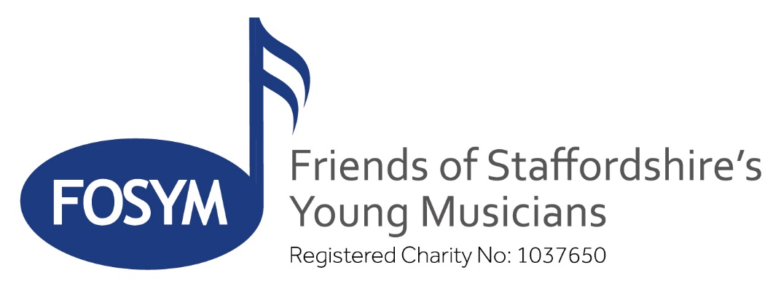

Parent/carer and school music teacher/headteacher or deputy must complete this form and then send it to [musicservice@entrust-ed.co.uk](mailto:musicservice@entrust-ed.co.uk)

All personal information is subject to our privacy notice (available on request)

**Parent or Carer Details**

Name:

Address: Postcode:

Contact email: Contact Mobile Number:

**Details of Pupil for FOSYM Award**

Name: Date of birth:

Name of School attended:

Instrument: Approximate current standard:

**Type of Lesson (please delete):** Individual / Shared

**Full Cost of Lessons per year: £**

**FOSYM contribution applied for (*usually up to 50% of total cost): £**

**Parent/Guardian Statement:** Please give a brief statement (use an additional sheet if required) to support the application for funding from FOSYM for your child, including relevant details of your financial circumstances, benefits received and how a FOSYM Award will support your child’s musical education.

**\*Please give further details of your financial position if you are applying for a more than 50% of the total cost of lessons**.

You sign to say that your statement is accurate and that you understand an annual progress report will be supplied to FOSYM by the teacher.

**Signed: Parent or Guardian: Date:**

**We would be interested in taking part in a case study** – YES / NO

**Music Service Recommendation:**

**Signed: Date:**

**School Comments in support of the application** **for the pupil named above:**

Comments:

I sign on behalf of the school in support of this application:

**Signed: Role: Date:**